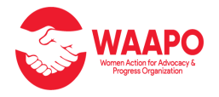

**_______________________________________________________________**

**IMPACT - REFLECTION REPORT FOR THE "EMPOWERING CHILDREN-IN SCHOOLS" UNDER THE SBC PROGRAM –funded by UNICEF**

**SBC Project Funded by UNICEF**

**Implementing agency: WAAPO**

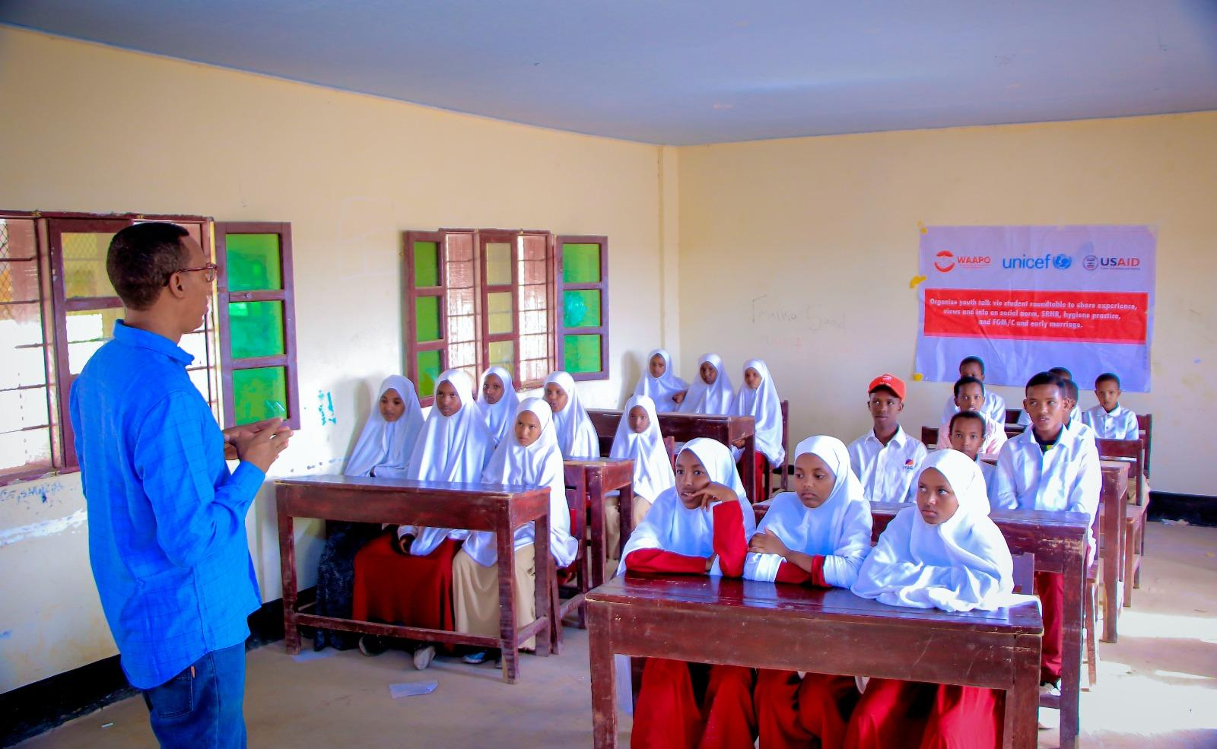

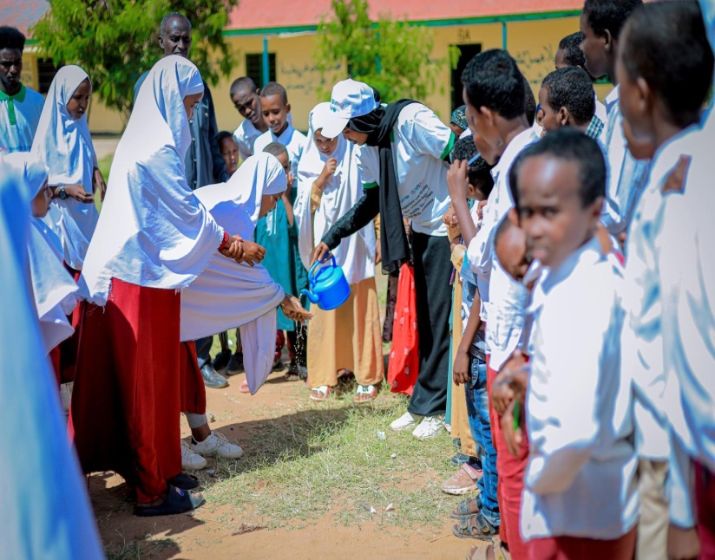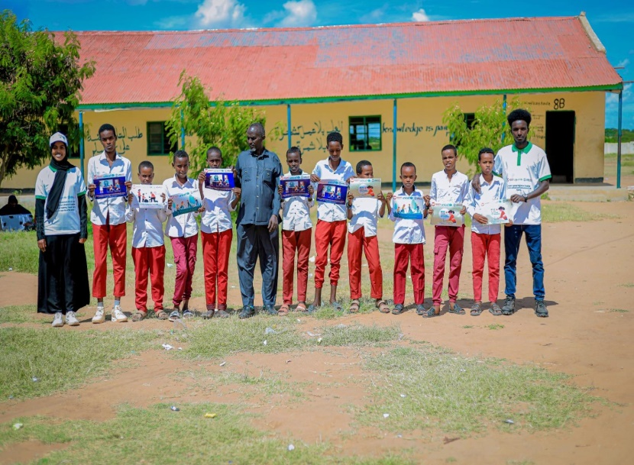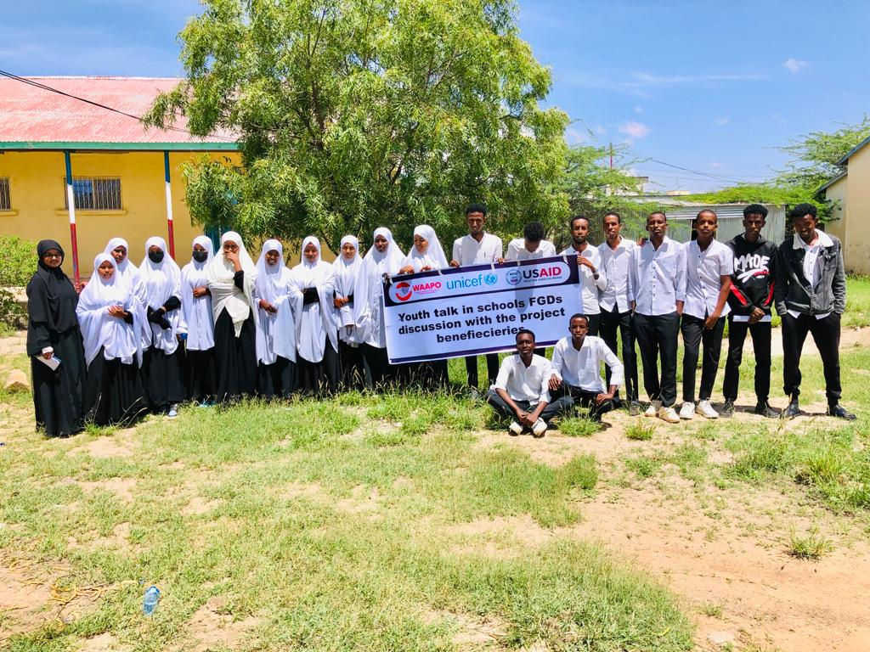

**Project Summary**

The integrated emergency response program for drought-affected communities, including Las,anood conflict, is a six-month emergence response program financed by UNICEF. The project targeted four regions, including Sool (including Lascanod), Sanag, Togdheer, and Marodijeex.  The program consist of child protection in emerging, SBC, Wash, and GBV for the most vulnerable people which was afflicted by conflict, climate change, and drought.

One of the most significant initiatives we are currently working on for the SBC Program is “Reduction in death and illness through promotion of healthy behaviour and demand for lifesaving services: Using the social & behaviour change approach.” This project will strengthen protection, social and behavioural change and accountability to the affected population, and to protect the most vulnerable women and girls and children affected by the drought through scaled up SBC program.

**Overview of the activates:**

The "Empowering Children-in Schools" session has been held as part of the SBC Program campaign in school and will include important topics such as child protection, hygiene promotion, and sexual and reproductive health and rights (SRHR).

The session aims to educate children with the knowledge and tools they need to protect them, practice good hygiene, and understand their rights in terms of their health and well-being.

By promoting child protection, hygiene, and SRHR, we empower school age boys and girls with the integration of the WAAPO-existing youth forum campaign called Her-in-Me school clubs; to make informed decisions, recognize their rights, and stay safe and healthy.

We believe, knowledge and attitude change for school-age children is power and receiving knowledge session through entertainment activities under the SBC program can create safe space and essential platform to ensure protection for children, hygine promotion essential information, MHPSS, SRHR.

The program has been developed to be run in one-day sessions in each of the project's target schools in Buhudle, Kalabydh, Cerigabo, Burco, and Gabily. The selection was discussed with school administration, and the ToRs of the activities, including objective and topic areas, were provided.

The project targeted 17-20 school-age boys and girls in the project's target school, and sessions were held in the morning and afternoon depending on the needs of the students and their availability.

The overall aim of these activities is incl.

* To provide children with the knowledge and resources they need to protect themselves, practice basic hygiene, and understand their SRHR.
* To promote child protection, hygienic habits, and SRHR through engaging and entertaining activities between children.
* Promoting children's rights in schools through the SBC campaign in order to bring about long-term change in mindset and establish a safe environment.

During the program, **the key thematic areas of focus for the session** are incl. Menstruation and Menstrual hygiene, healthy relationships, understanding puberty, body autonomy and age-appropriate language, forms and types of child protection in general, rights and responsibilities for the children, raising awareness on issues around corbel punishment, FGM, early marriage rape, available service for child abuse and ways to seek support. As well as Importance of hygiene, proper hand washing, oral hygiene (brush the teeth), personal hygiene, and environment hygiene roles.

The five main components we have been addressing throughout the program intervention are incl. . 1. Social behaviour change in schools related ( FGM/ Force marriage and corporal punishment 2. SRHR Campaign, 3. Hygiene Promotion 4. Child Protection 5.Mental health in school and child nutrition.

**List of the schools that the project were targeting are include:**

|  |  |
| --- | --- |
| School Name | Location |
| Alif Doon | Hargeisa |
| Dayib Guray School | Hargeisa |
| Sheekh Muxumed Warsame Primary School | Gabiley |
| Koosaar Primary School | Burco |
| Suusle Primary School | Burco |
| Saado Primary School | Ceeragabo |
| Candlelight Primary School | Ceeragabo |
| Salaama Orphan Center | Buhuudle |
| Samatar Primary and Secondary School | Buhuudle |
| School Name | Location |
| Alif Doon | Hargeisa |
| Dayib Guray School | Hargeisa |
| Sheekh Muxumed Warsame Primary School | Gabiley |
| Koosaar Primary School | Burco |
| Suusle Primary School | Burco |
| Saado Primary School | Ceeragabo |
| Candlelight Primary School | Ceeragabo |
| Salaama Orphan Center | Buhuudle |
| Samatar Primary and Secondary School | Buhuudle |

**Main activates throughout the program period are include:**

1. Conduct school clubs outdoor activities and hero-in-me school clubs meetings on parental knowledge of positive child-rearing, & protection of harm and abuse for the children.
2. Organize youth talk vie student roundtable to share experience, views and info on social norm, SRHR, hygiene practice, and FGM/C and early marriage.
3. Youth talk in schools FGDs discussion with the project beneficiaries

**Main progress against the core activities**:

During the reported period from March – August, 2023. **A total 1210 person** ( 790Girls, 420Boys ) of hero-in-me school clubs meetings on parental knowledge of positive child-rearing, & protection.

During the reported period from March – August, 2023. **A total 1410 Persons** ( 720 Girls; 690 Boys ) has been attended youth talk vie student roundtable on issue around social norm, SRHR, hygiene practice, and FGM/C and early marriage.

During the reported period from March – August,2023 **a total of 530 persons** ( 320 Girls, 210 Boys) has been participated FGDs discussion with the project beneficiaries incl. school and Non-school children.

Key earnings concern and challenges:

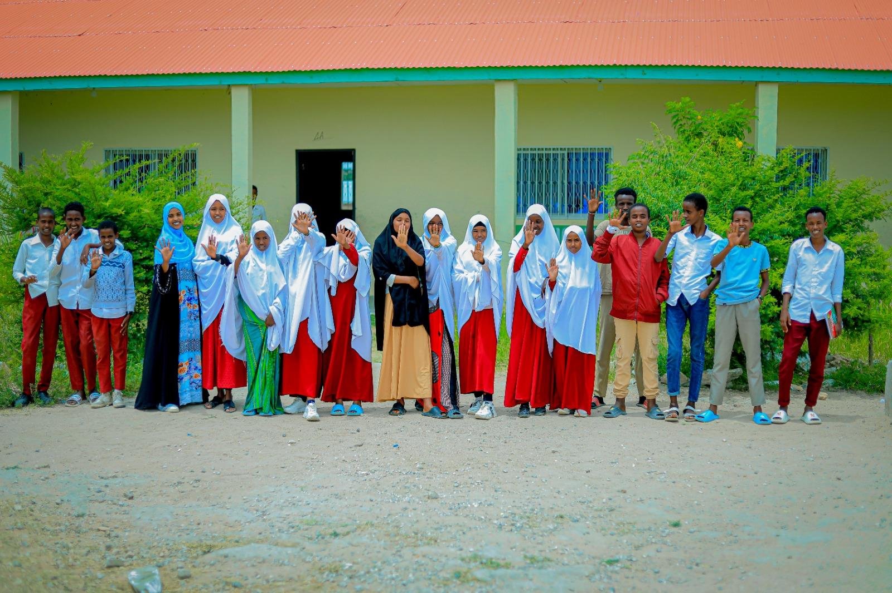**Key concerns that our frontline workers reported include** limited access to hygiene facilities: The project target schools do not have hand washing stations or limited access to clean water and soap, making it challenging for children to maintain proper hygiene as well as the difficulty of practicing social distancing, which can be challenging in crowded classrooms and transportation. Moreover, most of the project target schools are located in the IDPs, and they actually have an issue sharing books, stationary, or other materials, which can increase the risk of dropping out due to financial constraints.

Disruption of routines & social connections during the vacation that contribute loss of daily structure and reduced social interactions, causing feelings of isolation and loneliness among children in schools were also reported student “ *I’m don’t like to go the holiday becouse I don’t have family friends I can be socialised or someone I can trust the most*.” Said Faisa, 15*

The Academic pressures for young girls was also reported; some of the girl participants were reported that they do more on home choirs and they acing academic challenges due to interrupted schooling can lead to increased pressure and decreased motivation, impacting children's mental well-being.

School children nutrition was also noted and they have been informed that they do not always get their breakfast when they come to school, since most of them are originally from poor backround families – particularly schools in the IDPs.

All the girls in schools were reported that they they want through FGM between the ages of 7 and 14, and that they are all at risk of force marriage owing to economic pressure. "*My mother is always telling me that I'll be given to someone who knows the family because I  should end my marriage for a trusted person - whom they consider a family member, and she is not open to my decisions and choices*." Sayd Sacdia 14* years old.

Severe corporal punishment were also major concerns in schools - which is related social behaviour change and mind-set of the teachers and parents; that we would like to see in schools under this program; and they informed us that they all experienced through these children.

Recommended action and way-forward; to address those challenges the project is recommended:

Our  frontline worker also recommended in school to continue organize groups activities to encourage group work for the children in school such as debate, presentation or problem solving, Peer-to-Peer Learning that are dedicate child protection hygiene promotion, MHPSS and SRHR, improve children effective communication though class-room facilitation discussions to encourage children express their opinion and organize extracurricular activities in schools to address MHPSS, limited info for CP, SRHR, hygiene knowledge  & topics related social behaviours change. They have also suggested incorporating social-emotional learning programs into the curriculum through celebrations, events, and school clubs. WAAPO social workers emphasize the importance of school clubs and hero-in-me school clubs and their importance in raising anything that concerns the children

Throughout the program, we have also recommended that target schools be distributed with proper hygiene facilities, including hand washing stations and sanitization protocols, as well as education about the importance of hygiene practices and providing them with necessary supplies.

In schools, they do have mental health issues that affect children. In our learning, we have discovered that our SWs suggested offering mental health support services in the nearby IDP school, including counseling, MHPSS, or access to external resources, either in-person or through remote means (an online counseling program in schools), which is very essential.

In our context, there is limited communication and relationships between teachers, students, and parents. WAAPO SWs were also suggested to establish regular communication channels to foster a supportive and inclusive school culture that promotes understanding, empathy, and resilience among students by setting up class coordinators, a school union, establishing terms of reference, and providing trainings, forums, and sessions among the students and teachers in order to address such mental health concerns and reduce child abuse, corporal punishment, and school hygiene, as well as social behaviour change topics. Since the majority of the schools we targeted were on the IDP site, a school feeding program was also proposed, which will boost nutrition for the children in school and school attendance.

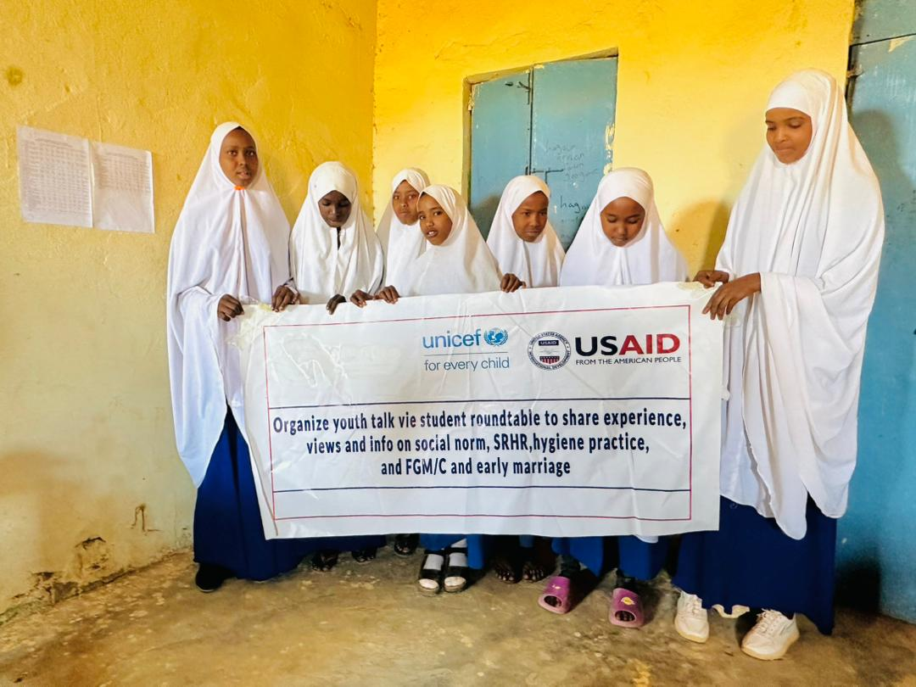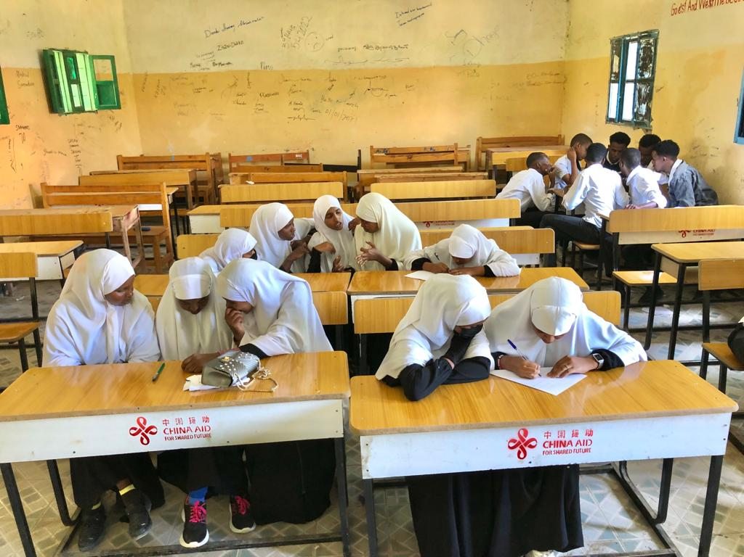Annex 1: Quality Picture

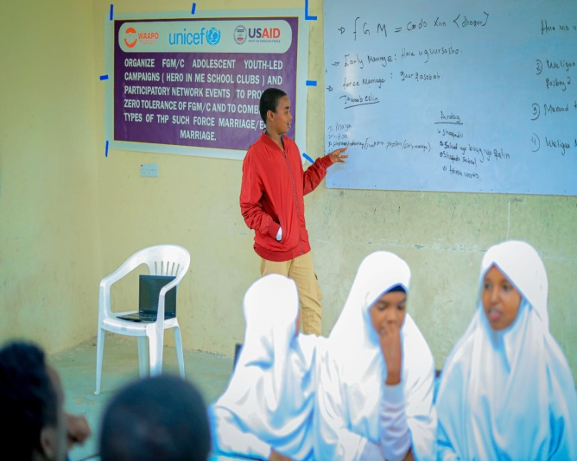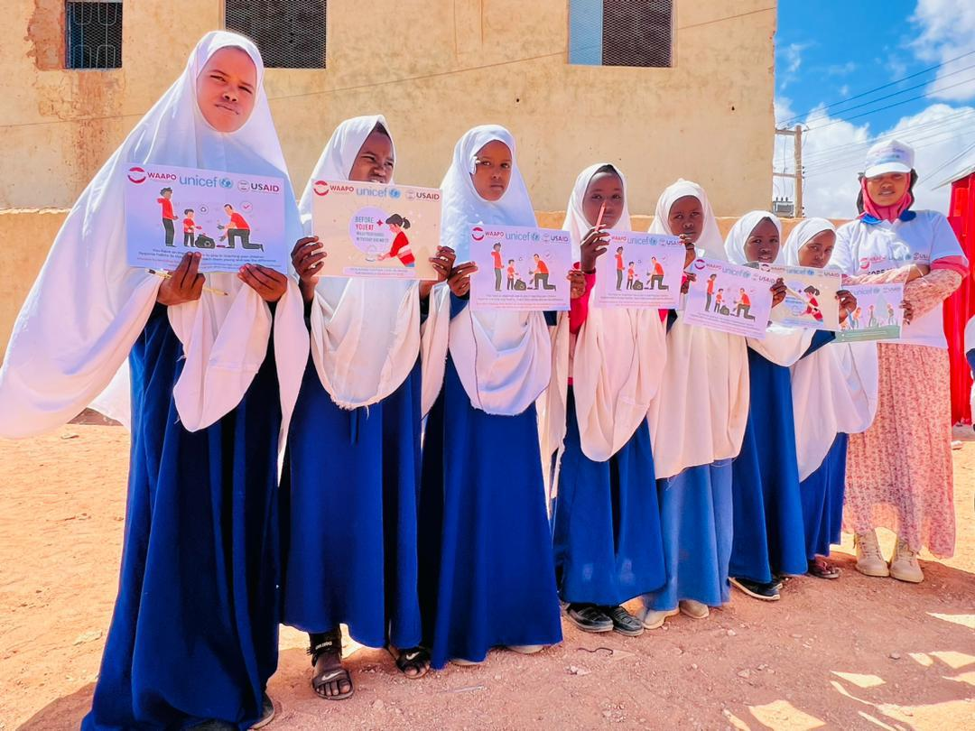

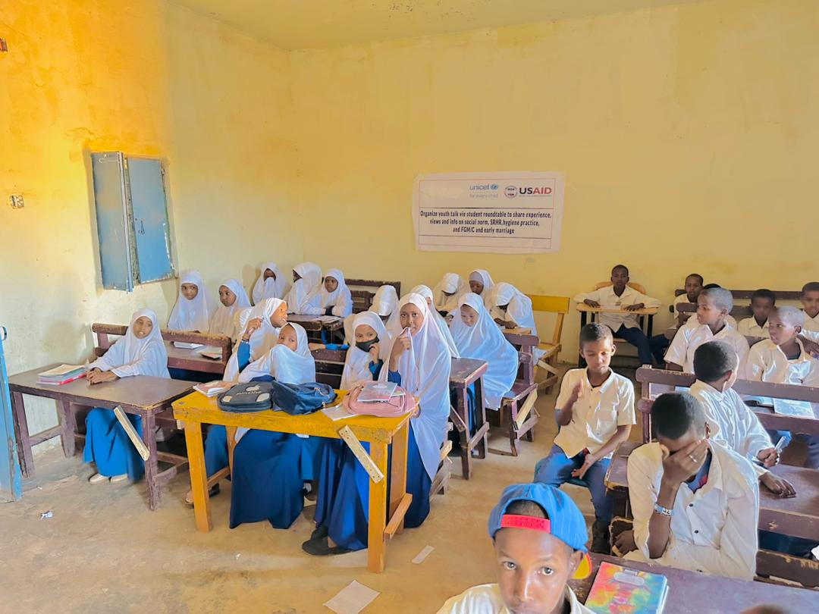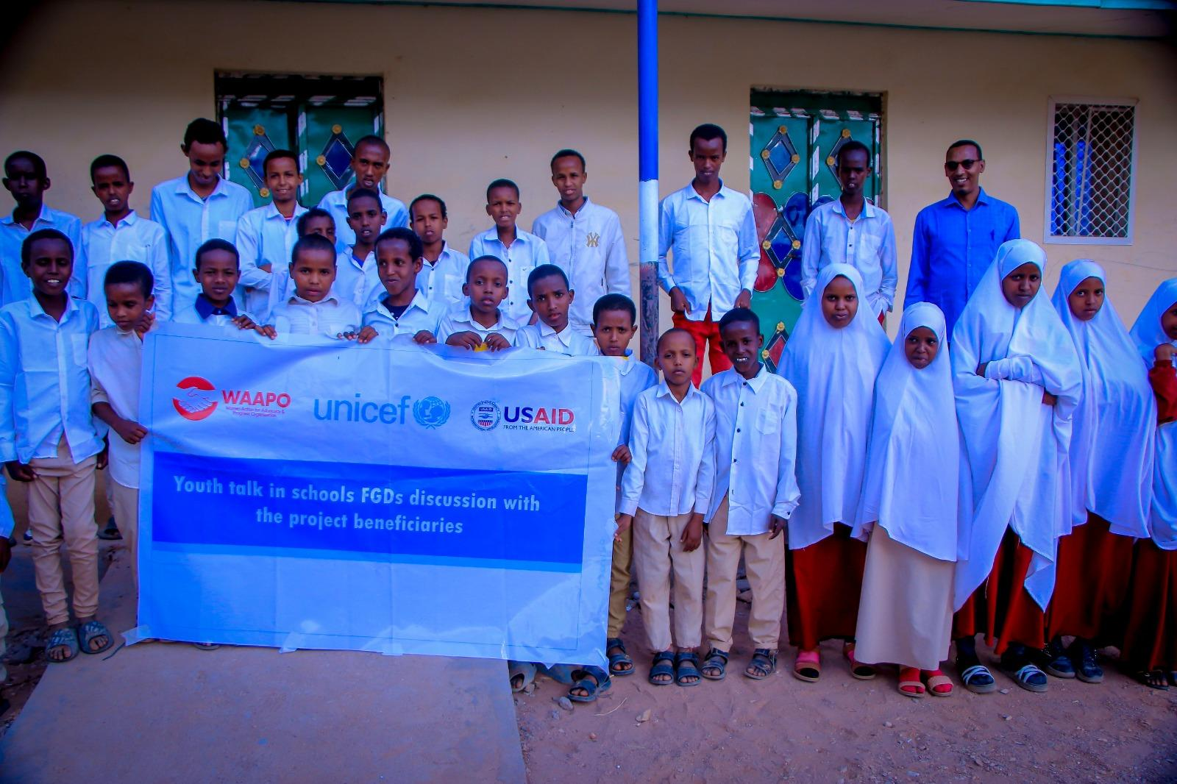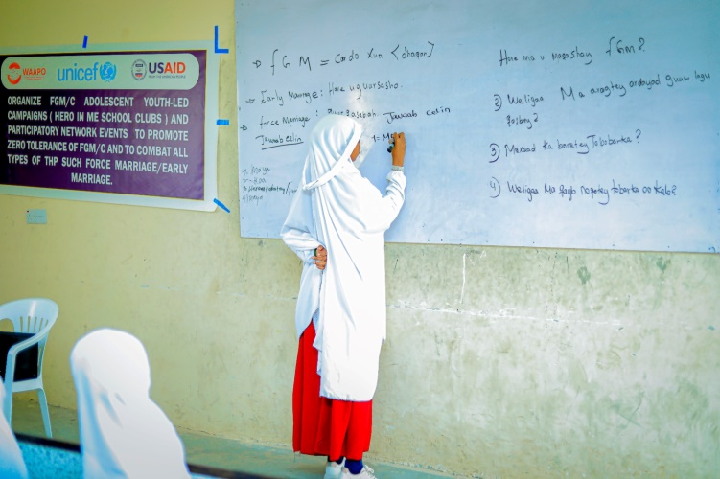

Annex 2 : Program Schedule of the sessions

* II. Child Protection (20 minutes)
* Definition and Importance
  + Explain the concept of child protection and why it is crucial for children's safety and well-being.
* Rights and Responsibilities
  + Introduce the United Nations Convention on the Rights of the Child (UNCRC) and discuss the rights and responsibilities of children.
* Identifying Safe and Unsafe Situations
  + Engage the children in a discussion to help them identify safe and unsafe situations. Provide examples and encourage them to share their experiences or concerns.
* Strategies for Seeking Help
  + Teach the children how and when to seek help if they feel unsafe or encounter a dangerous situation. Discuss trusted adults and helpline numbers they can reach out to.

III. Hygiene Promotion (20 minutes)

* Importance of Hygiene
  + Explain the significance of maintaining good hygiene practices for overall health and well-being.
* Hand Hygiene
  + Demonstrate proper hand washing techniques, emphasizing the importance of washing hands with soap and water, especially before meals and after using the toilet.
* Oral Hygiene
  + Discuss the importance of oral hygiene and encourage the children to brush their teeth regularly.
* Personal Hygiene.
  + Talk about the importance of bathing, wearing clean clothes, and keeping nails trimmed to maintain personal hygiene.
* Environmental Hygiene
  + Explain the significance of keeping their surroundings clean and the role it plays in preventing diseases.

IV. SRHR Campaign (20 minutes):

* Introduction to SRHR
  + Introduce the concept of sexual and reproductive health and rights, using age-appropriate language and examples.
* Body Autonomy and Consent
  + Discuss the importance of body autonomy, personal boundaries, and consent. Teach children how to recognize and respect their own and others' boundaries.
* Understanding Puberty
  + Provide age-appropriate information about puberty, physical changes, and emotional well-being during this stage of life.
* Menstruation and Menstrual Hygiene
  + Address the topic of menstruation, explaining the biological process and promoting menstrual hygiene practices.
* Healthy Relationships
  + Discuss the characteristics of healthy relationships, emphasizing respect, communication, and consent.
* Available Support and Resources
  + Share information about available support systems, such as counselors, helplines, and educational resources related to SRHR.